

University Grievance Management System

Group Number: 13

Guided By:

Dr. Jignesh Doshi

Dr. Anuradha Acharya

Project By:

Vasani Utsavkumar 2020004500210083

Kathrotiya Bhautik 2020004500210081

Satasiya Khushi 2020004500210055

GitHub Link:

<https://github.com/Bhautik01/Grievance-management-system>

Index

# 1.Introduction……………………………………………………………

# Existing System …………………………………………………..................................

# Need for the New System …………………………………………….…......................

# Objective of the New System …………………………………………........................

# Problem Definition …………………………………………………….......................

# Core Components ……………………………………………………………………......

# Project Profile ……………………………………………………………………………..

# Advantages of the Proposed System ………………….………………......................

1.8 Limitations of the Proposed System…………………………………………………….

2.Require Determination & Analysis

2.1 Requirement Determination………………………………………………………………

2.2 Targeted Users …………………………………………………………………………….

# 3.System Design…………………………………………………………

# Use Case Diagram ………………………………………………………………………….

# Data Dictionary ………………………………………………………..............................

# 4.Development **…**……………………………………………………..................

# 4.1 Screenshots ………………………………………………………….………………………

# 5.Conclusion …………………………………………………………....

# 6.Bibliography ………………………………………………………….

1. INTRODUCTION

A university grievance management system is a process that universities use to handle student, faculty, and staff complaints and concerns effectively. The system typically includes a set of policies and procedures that ensure grievances are handled in a timely, fair, and confidential manner.

The primary goal of a university grievance management system is to provide an avenue for students, faculty, and staff to voice their grievances and have them resolved in a fair and equitable manner. It helps to create a positive and supportive university community that values feedback and continuous improvement.

* 1. Existing System

Typically, universities have a designated office or department responsible for receiving and handling grievances. This may be called the Office of Student Affairs, Office of Human Resources, or Office of Faculty Affairs, depending on the nature of the grievance.

* 1. Need For The New System

While the existing university grievance management systems aim to provide a fair and transparent process for addressing grievances, there may be a need for a new system to address some of the limitations of the current system.

* 1. Objective Of The New System

The objective of a new university grievance management system is improving responsiveness, Enhancing transparency, Ensuring consistency, increasing accessibility, Promoting accountability and Facilitating continuous improvement.

* 1. Problem Definition

In current scenario, students have to go to college premises to register complaint or to get status of registered complaint. Also college administrations have to allocate human resource to examine and resolve the complaint. These make whole process tedious. These problems can lead to a lack of trust in the grievance management system and can make it difficult to resolve complaints effectively.

* 1. Core Component

**Student:** In grievance management system student can login the system and register their complaints and view their complain history. And student can raise complaint and gives the feedback. Student can change their password and logout or exit the system.

**Admin:** Admin can login and change their password and admin can logout or exit the system. Admin also manage an organizational structure of university and manage a user. Admin can view pending and closed complaints

**Problem Solver:** problem solver can login and change their password and problem solver can logout or exit the system. Problem solver checks a grievance and try to solve grievance and can complaint to the upper level of organizational structure. After resolving a grievance they notify to the Student and checks a feedback. They can manage their profile and check pending status of grievance.

* 1. Project Profile

**Student:**

1. Registration
2. Login
3. Forgot Password
4. Reset password
5. Post Their Complain
6. Check The Status Of Complain
7. Can Send Feedback
8. Manage Profile

**Admin:**

1. Login
2. Forgot Password
3. Reset password
4. Can see Complains
5. Can manage User
6. Can Manage user’s Data
7. Can Manage Complains
8. Mange Profile
9. Check A Feedback

**Resolver:**

1. Registration
2. Login
3. Forgot Password
4. Reset password
5. Can see Complains
6. Solves Complains
7. Change The status of Complain
8. Ends Unwanted Complain Forcefully
9. Can Pass Complain To the Upper Level Of Organization
10. Manage Profile
    1. Assumptions and Constrains

We are assuming that user have a computer devices. We are assuming that user is a capable to interact with computer devices for grievance. We are assuming that they have proper network connections. We cannot use system without having computer and internet Connections.

* 1. Advantages and limitations

**Advantages:**

* The new system will manage the problem and their status.
* No possibility of communication gap.
* Instant report generation for any complaint can be obtained.
* New system will ensure smooth side between the management and students.

**Limitations:**

* The current system is manual and time consuming.
* Communication gap is the biggest problem in such a system.
* The students / faculty may not be aware/conveyed the problems status.
  1. Targeted User

Our system has three types of users they are as follows:

1. Admin
2. Student
3. Members of organizations
4. SYSTEM DESIGN
   1. use case diagram



**Registration**

**Log In**

**Manage User**

**Manage Data**

**Student**

**Manage Complain**

**View Status**

**Manage Profile**



**View Report**

**Manage Hierarchy**

**Manage Status**

**Make Report**

**Make Complains**

**Admin**

**View Solution**

**Pending Complains**

**View Feedback**



**Logout**

**Feedback**



**Member Of**

**Organization**

* 1. Activity Diagram

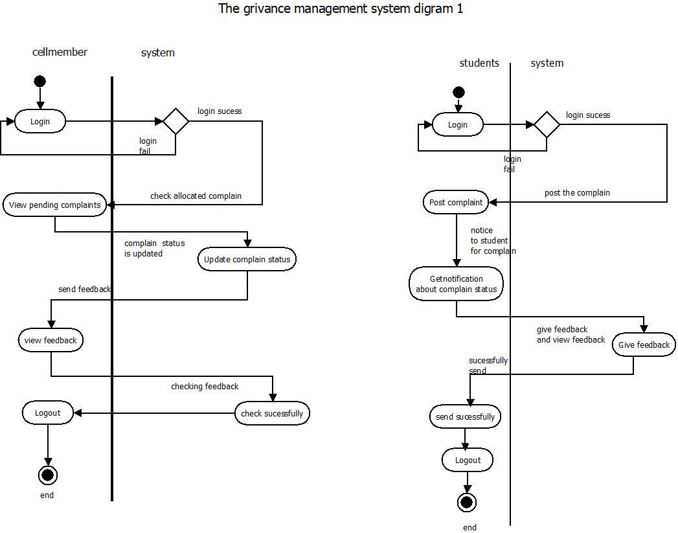

Students

Orgenization member

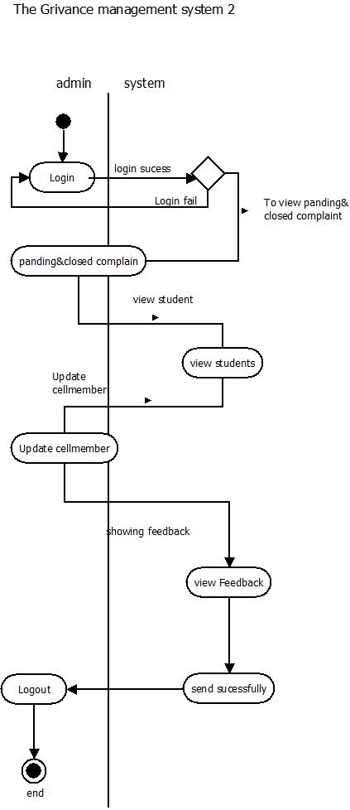

* 1. Data Dictionary

1. **Table Name:** Collage

|  |  |  |  |  |
| --- | --- | --- | --- | --- |
| Field Name | Data Type | Constraint | Description | Sample Data |
| collageId | Int | Primary key | Colleg identification | 1001 |
| collageName | Varchar2(30) | Not Null | Name Of Collage | “LJ institute of Computer Application” |
| Collage Address | Varchar2(50) | Not Null | Address Of Collage | Ahmedabad |

1. **Table Name:** Department

|  |  |  |  |  |
| --- | --- | --- | --- | --- |
| Field Name | Data Type | Constraint | Description | Sample Data |
| departmentId | Int | Primary key | Identification of department | 2001 |
| collageId | Int | Foreign key | Reference key of college id | 1001 |
| DepartmentName | Varchar2(50) | Not Null | Name of department | M.Sc.IT. |

1. **Table Name:** Designation

|  |  |  |  |  |
| --- | --- | --- | --- | --- |
| Field Name | Data Type | Constraint | Description | Sample Data |
| designationId | Int | Primary key | Identification of designation | 3001 |
| Sem | Int | Not Null | Number Of Semester | 6 |

1. **Table Name:** Feedback

|  |  |  |  |  |
| --- | --- | --- | --- | --- |
| Field Name | Data Type | Constraint | Description | Sample Data |
| feedbackId | Int | Primary key | Identification of feedback | 4001 |
| complainId | Int | Foreign key | Identification of Complain | 5001 |
| message | Varchar2(100) | Not Null | Message Of Feedback | “thank you” |
| FeedbackDate | Date | Not Null | Date of feedback | 27/03/2023 |

1. **Table Name:** Complain

|  |  |  |  |  |
| --- | --- | --- | --- | --- |
| Field Name | Data Type | Constraint | Description | Sample Data |
| ComplainId | Int | Primary key | Identification of complain | 5001 |
| fromId | Int | Foreign key | Identification of Sender | 6001 |
| toId | Int | Foreign key | Identification of Receiver | 6002 |
| About | Varchar2(100) | Not Null | Subject Of Complain | Educational |
| complain | Varchar2(100) | Not Null | Message Of Complain | “dustbin is not proper” |
| complainDate | Date | Not Null | Date of Complain | 27/03/2023 |
| Status | Int | Not Null | Completed, Pending, Dismissed | 0,1,2 |
| Solution | Varchar2(200) | Null | How Complain Solved | “we have put new dustbin” |
| solutionDate | Date | Null | Date of Solution | 30/03/2023 |

1. **Table Name:** Members

|  |  |  |  |  |
| --- | --- | --- | --- | --- |
| Field Name | Data Type | Constraint | Description | Sample Data |
| memberId | Int | Primary key | Identification of member | 6001 |
| memberName | Varchar2(50) | Not Null | Name of Number | “utsav vasani” |
| collageId | Int | Foreign key | Identification of Collage | 1 |
| departmentId | Int | Foreign key | Identification of Department | 2 |
| DesignationId | Int | Foreign key | Identification of Designation | 3 |